|  |  |  |  |
| --- | --- | --- | --- |
| 1 | | 14,841.857142857143 | |
| NUMERO DE FRONTERAS | | ENERGIA AGREGADA | |
|  | | | |
|  | |  | |
| CONTRATO | | VENCIMIENTO CONTRATO | |
|  | | | |
| 48,457,655 | 133 | | 1,776,746 |
| INGRESO 2019 | DÍAS CERTIFICADOS 2019 | | ENERGIA RESPALDADA 2019 |
|  | | | |
| 65,858,308 | 191 | | 2,481,684 |
| INGRESO 2020 | DÍAS CERTIFICADOS 2020 | | ENERGIA RESPALDADA 2020 |
|  | | | |
| 33,929,956 | 114 | | 1,480,164 |
| INGRESO 2021 | DÍAS CERTIFICADOS 2021 | | ENERGIA RESPALDADA 2021 |

|  |
| --- |
| **CLINICA PORTO AZUL**  USUARIO |

|  |
| --- |
| **Edwin Torres**  Ejecutivo de cuenta |

|  |
| --- |
| **Sebastian Botero / Ingeniero de Mantenimiento / sebastian.botero@clinicaportoazul.com**  PUNTO FOCAL |

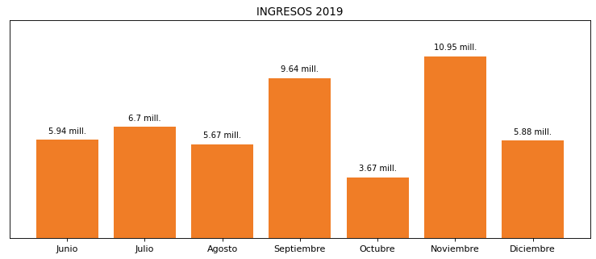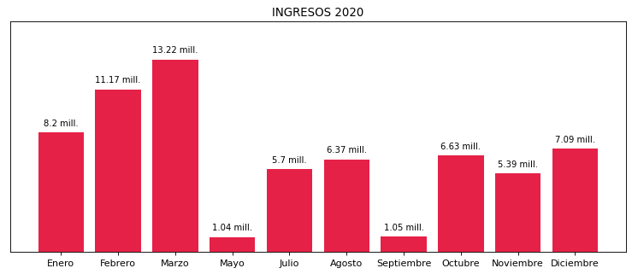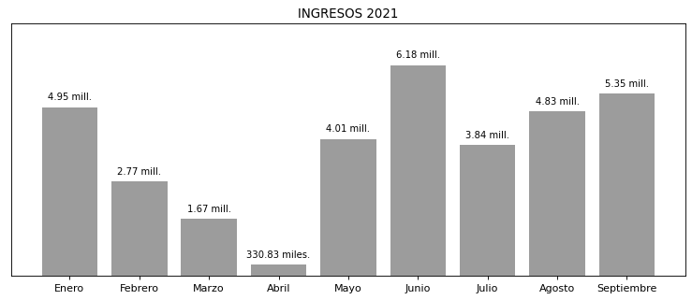

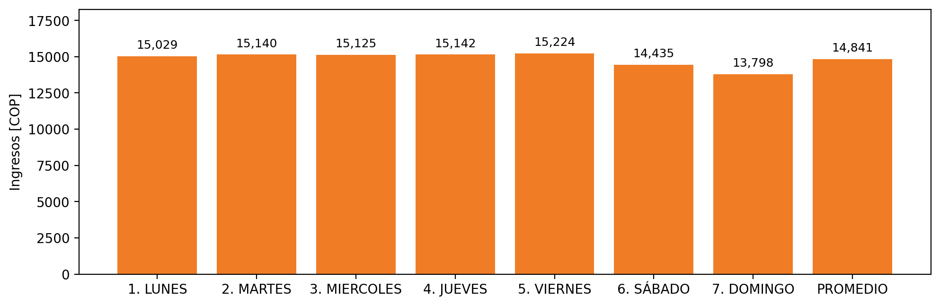

|  |  |  |  |  |  |  |  |  |  |  |
| --- | --- | --- | --- | --- | --- | --- | --- | --- | --- | --- |
| **FRONTERA** | **COD SIC** | **PREDIO** | **FRT DDV** | **TIPO DDV** | **PROMEDIO** | **PRÓXIMA ACTUALIZACIÓN** | **MARGEN DE ERROR** | **ÚLTIMA PRUEBA DDV** | **DÍAS PARTICIPACIÓN** | **FECHA REFERENCIA PRÓXIMA PRUEBA DDV** |
| CLINICA PORTO AZUL S.A. - CPA | Frt20561 | Prd01247 | Frt32406 | LBC | 14,841 | 2022-03-04 | 2,18 | 2021-10-14 | 0.0 | 2022-02-21 |